**Bank loan report query doc**

1. Bank loan applications

SELECT COUNT(id) AS total_loan_applications FROM bank_loan_data;

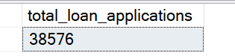

1. MTD loan applications

SELECT COUNT(id) AS mtd_total_loan_applications FROM bank_loan_data

WHERE MONTH(issue_date) = 12 AND YEAR(issue_date) = 2021;

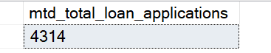

1. PMTD loan applications

SELECT COUNT(id) AS pmtd_total_loan_applications FROM bank_loan_data

WHERE MONTH(issue_date) = 11 AND YEAR(issue_date) = 2021;

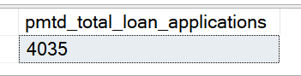

--to calculate MoM = (MTD-PMTD)/PMTD

1. Total funded (loan) amount

SELECT SUM(loan_amount) AS total_funded_amount FROM bank_loan_data;

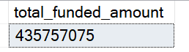

1. MTD total loan amount

SELECT SUM(loan_amount) AS mtd_total_funded_amount FROM bank_loan_data

WHERE MONTH(issue_date) = 12 AND YEAR(issue_date) = 2021;

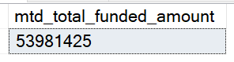

1. PMTD total loan amount

SELECT SUM(loan_amount) AS mtd_total_funded_amount FROM bank_loan_data

WHERE MONTH(issue_date) = 11 AND YEAR(issue_date) = 2021;

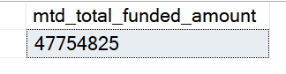

1. Total amount received (payment)

SELECT SUM(total_payment) AS total_amount_received FROM bank_loan_data;

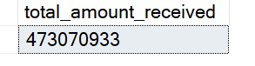

1. MTD amount received (payment)

SELECT SUM(total_payment) AS mtd_total_amount_received FROM bank_loan_data

WHERE MONTH(issue_date) = 12 AND YEAR(issue_date) = 2021;

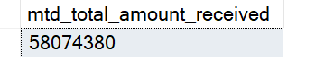

1. PMTD amount received (payment)

SELECT SUM(total_payment) AS pmtd_total_amount_received FROM bank_loan_data

WHERE MONTH(issue_date) = 11 AND YEAR(issue_date) = 2021;

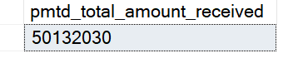

1. Average interest rate

SELECT ROUND(AVG(int_rate), 4) * 100 AS avg_interest_rate FROM bank_loan_data;

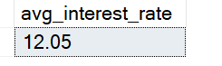

1. MTD Average interest rate

SELECT ROUND(AVG(int_rate), 4) * 100 AS mtd_avg_interest_rate FROM bank_loan_data

WHERE MONTH(issue_date) = 12 AND YEAR(issue_date) = 2021;

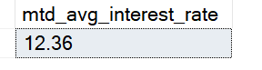

1. PMTD Average interest rate

SELECT ROUND(AVG(int_rate), 4) * 100 AS pmtd_avg_interest_rate FROM bank_loan_data

WHERE MONTH(issue_date) = 11 AND YEAR(issue_date) = 2021;

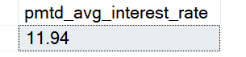

1. Average debt-to-income ratio (DTI)

SELECT ROUND(AVG(dti), 4) * 100 AS avg_dti FROM bank_loan_data;

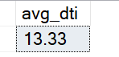

1. MTD average debt-to-income ratio (DTI)

SELECT ROUND(AVG(dti), 4) * 100 AS mtd_avg_dti FROM bank_loan_data

WHERE MONTH(issue_date) = 12 AND YEAR(issue_date) = 2021;

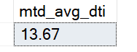

1. PMTD average debt-to-income ratio (DTI)

SELECT ROUND(AVG(dti), 4) * 100 AS pmtd_avg_dti FROM bank_loan_data

WHERE MONTH(issue_date) = 11 AND YEAR(issue_date) = 2021;

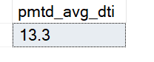

Good loan vs. Bad loan KPI’s

1. Good loan application percentage

SELECT

(COUNT(CASE WHEN loan_status = 'Fully Paid' OR loan_status = 'Current' THEN id END) * 100)

/

COUNT(id) AS good_loan_percentage

FROM bank_loan_data;

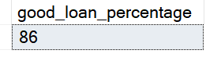

1. Total number of good loan applications

SELECT COUNT(id) AS good_loan_applications FROM bank_loan_data

WHERE loan_status = 'Fully Paid' OR loan_status = 'Current';

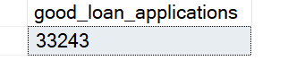

1. Good loan funded amount

SELECT SUM(loan_amount) AS good_loan_funded_amount FROM bank_loan_data

WHERE loan_status = 'Fully Paid' OR loan_status = 'Current';

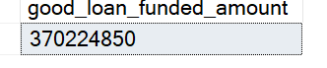

1. Good loan total received amount

SELECT SUM(total_payment) AS good_loan_received_amount FROM bank_loan_data

WHERE loan_status = 'Fully Paid' OR loan_status = 'Current';

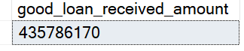

1. Bad loan application percentage

SELECT

(COUNT(CASE WHEN loan_status = 'Charged Off' THEN id END) * 100.0)

/

COUNT(id) AS bad_loan_percentage

FROM bank_loan_data;

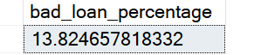

1. Total number of bad loan applications

SELECT COUNT(id) AS bad_loan_applications FROM bank_loan_data

WHERE loan_status = 'Charged Off';

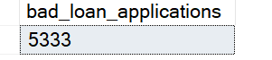

1. Bad loan funded amount

SELECT SUM(loan_amount) AS bad_loan_funded_amount FROM bank_loan_data

WHERE loan_status = 'Charged Off';

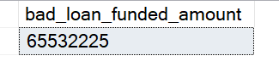

1. Bad loan total received amount

SELECT SUM(total_payment) AS bad_loan_received_amount FROM bank_loan_data

WHERE loan_status = 'Charged Off';

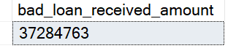

Loan status grid view

1. Loan status

SELECT

loan_status,

COUNT(id) AS total_loan_applications,

SUM(total_payment) AS total_amount_received,

SUM(loan_amount) AS total_funded_amount,

AVG(int_rate * 100) AS avg_interest_rate,

AVG(dti * 100) AS dti

FROM bank_loan_data

GROUP BY loan_status;

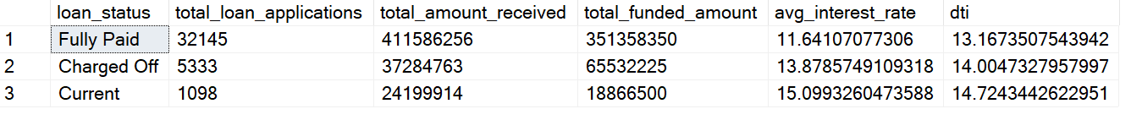

1. MTD loan status

SELECT

loan_status,

COUNT(id) AS mtd_total_loan_applications,

SUM(total_payment) AS mtd_total_amount_received,

SUM(loan_amount) AS mtd_total_funded_amount,

AVG(int_rate * 100) AS mtd_avg_interest_rate,

AVG(dti * 100) AS mtd_dti

FROM bank_loan_data

WHERE MONTH(issue_date) = 12

GROUP BY loan_status;



DASHBOARD #2

1. Monthly trend by issue date

SELECT

MONTH(issue_date) AS month_number,

DATENAME(MONTH, issue_date) AS month_name,

COUNT(id) AS total_loan_applications,

SUM(total_payment) AS total_amount_received,

SUM(loan_amount) AS total_funded_amount

FROM bank_loan_data

GROUP BY MONTH(issue_date), DATENAME(MONTH, issue_date)

ORDER BY MONTH(issue_date);

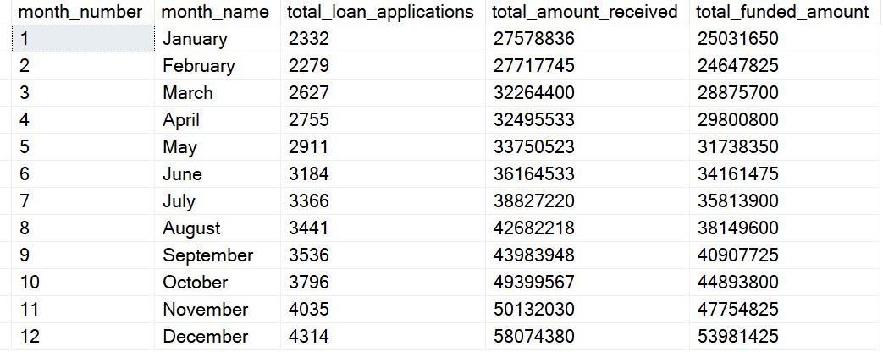

1. Regional analysis by state

SELECT

address_state,

COUNT(id) AS total_loan_applications,

SUM(total_payment) AS total_amount_received,

SUM(loan_amount) AS total_funded_amount

FROM bank_loan_data

GROUP BY address_state

ORDER BY COUNT(id) DESC;

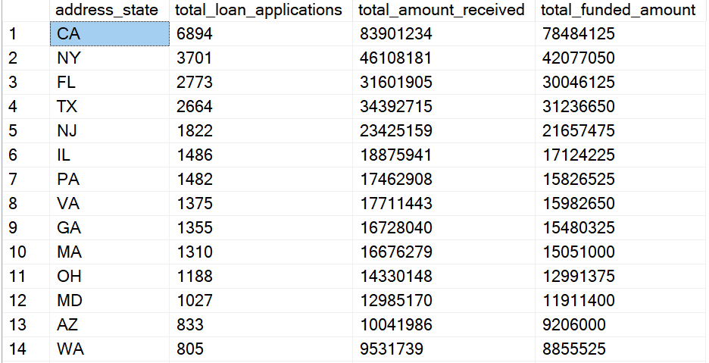

1. Loan term analysis

SELECT

term,

COUNT(id) AS total_loan_applications,

SUM(total_payment) AS total_amount_received,

SUM(loan_amount) AS total_funded_amount

FROM bank_loan_data

GROUP BY term

ORDER BY term;

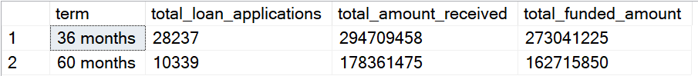

1. Employee length analysis

SELECT

emp_length,

COUNT(id) AS total_loan_applications,

SUM(total_payment) AS total_amount_received,

SUM(loan_amount) AS total_funded_amount

FROM bank_loan_data

GROUP BY emp_length

ORDER BY COUNT(id) DESC;

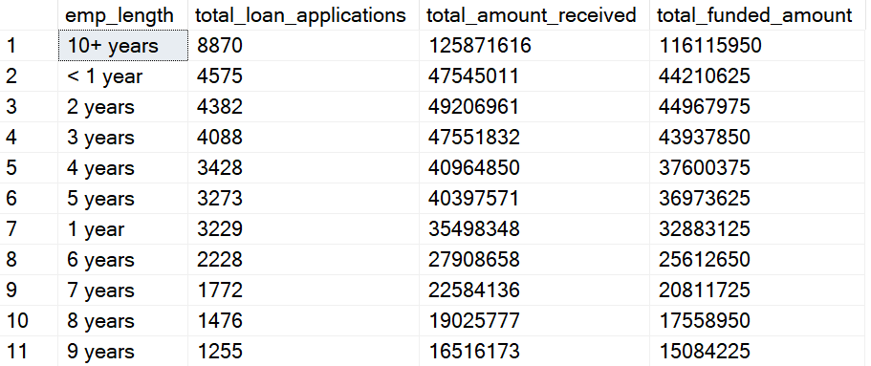

1. Loan purpose breakdown

SELECT

purpose,

COUNT(id) AS total_loan_applications,

SUM(total_payment) AS total_amount_received,

SUM(loan_amount) AS total_funded_amount

FROM bank_loan_data

GROUP BY purpose

ORDER BY COUNT(id) DESC;

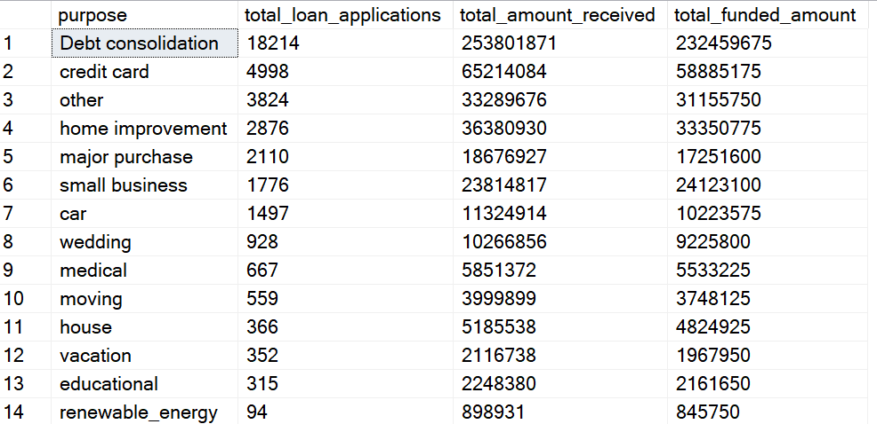

1. Homeownership analysis

SELECT

home_ownership,

COUNT(id) AS total_loan_applications,

SUM(total_payment) AS total_amount_received,

SUM(loan_amount) AS total_funded_amount

FROM bank_loan_data

GROUP BY home_ownership

ORDER BY COUNT(id) DESC;

